CREATIVE EDUCATIONAL SERVICES KAMPALA
MID TERM I EXAMINATION 2024
NUMBERS
PRIMARY TWO

Time allowed: 1 hour 30 minutes

My name is School
1. Name the set.
(a)

(b) Draw a set of 7 chairs.

2. Add correctly.
(a) 12 + 4 =

(b) 5 + 0 + 8 =

(c) | H | T | O
 | 6 | 2 | 5
+ 2 3 1

3. Write in words.
(a) 4 3

(b) 2 0 6

4. Subtract/Take away
(a) 12 eggs – 4 eggs =

(b) T O
5 9
- 3 3

5. Write the place value of the underlined digit.
(a) 6 4

(b) 7 8 2

6. Name these shapes.
(a) (b)

7. (a) 8 x 2 = (c) 3 0
x 3

(b) 1 3 4
x 2

8. Expand these numbers.
(a) (i) 5 3 = +

(ii) 7 3 5 = + +

(b) What number has been expanded?
40 + 6 =

9. (a) Write the correct time.
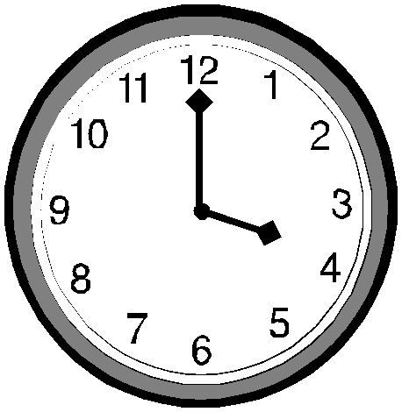

(b) Write the missing days.
Sunday, Monday, _, _, Thursday.

10. Write in figures.
(a) Seventy eight =

(b) Five hundred thirty four =

11. Find the missing numbers.
(a) 5, 10, 15, , 25, , 35

(b) 2, 4,
, 8, 10, , 14

12. Complete correctly.
(a) 9 3 = tens ones

(b) 6 hundreds 4 tens 3 ones =

13. Find the missing number.
(a) 6 + = 9

(b) - 7 = 3

14. (a) Shade a half

(b) 1 | + | 1
4 |  | 4

(c) Name the shaded fraction.

15. (a) What number is shown on the abacus?
H T O

=

(b) Show the number on the abacus.
T O

25 =

16. Compare these pencils.
(a) A B

(a) Which pencil is longer?

(b) Pencil is shorter.
17. Work out using the number line. (a) 3 + 5 =

0 1 2 3 4 5 6 7 8 9 10

(b) 7 - 3 =

0 1 2 3 4 5 6 7 8 9 10

18. Which number comes just; (a) after 100,

(b) before , 50

19. Study the pictures and answer the questions.

6 metres

4 metres
2 metres

 | (a) | What is the distance from the chair to the table?
20. | (b)  (a) | If Moses moved around the pictures, find the total distance he walked.  A stool has 3 legs. How many legs do 2 stools have?
 | (b) | 4 + 4 + 4 + 4 + 4 = x =
21. Musisi had 34 oranges. He gave us 12 of them. How many oranges remained?

22. Share 15 sweets equally among 5 girls. How many sweets does each get?

23. Rhoda has 45 hens. She buys another 31. How many hens does she have altogether?

24. Five boys corrected eggs as shown on the table.

Shafic
Ashraf
Moses
Abu
Juma

(a) How many eggs did Ashraf collect?

(b) Who collected the same number of eggs?
and

(c) How many eggs did they collect altogether

